CHECK OUT BOULDER

Boulder, Colorado is a progressive city at the base of the Flatirons, beautiful rock formations that provide a gateway to the Rocky Mountains. With over 200 miles of hiking and biking trails, Boulder is a dream come true for outdoor lovers. Book a trip to Boulder via Denver International Airport on Virgin America. Live it up at 35,000 feet with WiFi, on-demand entertainment, and more on every flight.

(MARKET IMAGE HERE)

Find Deals From These Cities

INSERT FARE GRID FROM / TO Version (if available!)

   
Top Things To Do in Boulder

When visiting Boulder, you can spend plenty of time in nature enjoying the beautiful surroundings. But there’s also plenty to do inside, from eclectic dining to fantastic microbreweries and an enticing pedestrian mall. Boulder is also home to a quickly growing technology industry with both established players like IBM and a wide variety of startups.

* Spend the day at Boulder’s hidden gem, Eldorado Canyon. If you’re up for an adventure, hike along the sandstone cliffs or climb the golden walls. For a more laid-back time, enjoy a picnic along South Border Creek. No matter what you choose to do here, you’ll have a great time!
* Window shop along Pearl Street Mall in downtown Boulder. With its fabulous combination of big brand stores, posh boutiques and trendy art galleries, there are a lot of interesting things to see. When you get hungry, grab a bite at one of the many restaurants or local cafes.
* Tea lover or not, plan to visit the Celestial Seasonings Tea Factory. Take the free tour to see the entire packaging process, Celestial Herb Garden, the popular Mint Room, and sample some of their best-selling teas.

Travel Tips and Resources

[Must-Dos in Boulderhttp://www.tripadvisor.com/Attractions-g33324-Activities-Boulder_Colorado.html](http://www.tripadvisor.com/Attractions-g33324-Activities-Boulder_Colorado.html)

[Boulder Hotelshttp://www.tripadvisor.com/Hotels-g33324-Boulder_Colorado-Hotels.html](http://www.tripadvisor.com/Hotels-g33324-Boulder_Colorado-Hotels.html)

[Boulder Restaurantshttp://www.tripadvisor.com/Restaurants-g33324-Boulder_Colorado.html](http://www.tripadvisor.com/Restaurants-g33324-Boulder_Colorado.html)

[Boulder Shopping Guidehttp://www.boulderdowntown.com/shopping](http://www.boulderdowntown.com/shopping)

[Boulder Nightlife and Entertainmenthttp://www.bouldercoloradousa.com/things-to-do/boulder-nightlife](http://www.bouldercoloradousa.com/things-to-do/boulder-nightlife)

[Boulder Travel Tipshttp://travel.usnews.com/Boulder_CO/Travel_Tips](http://travel.usnews.com/Boulder_CO/Travel_Tips)

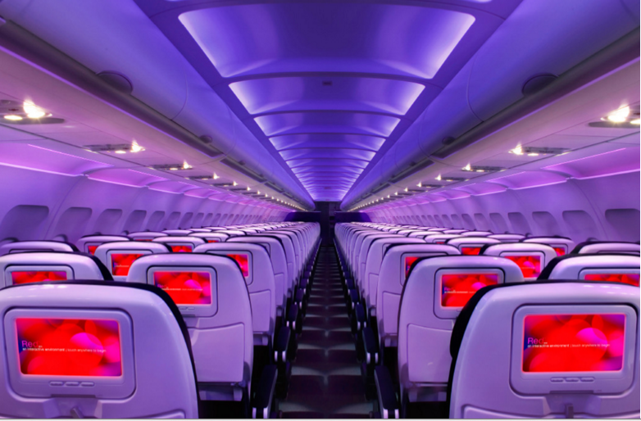

Main Cabin Main Cabin Select First Class

(add links to Cabin Class Pages)

Ready. Set. Fly.

Book your Mood-lit Ride to Boulder.

Looking into flights to Boulder, CO, you’ll discover Boulder is served by Denver International Airport. The next time you’ll be visiting Boulder, travel in style and book your flight to Denver with Virgin America. Our custom-designed leather seats provide an unparalleled level of comfort. Our mood-lit cabins were thoughtfully crafted with your relaxation in mind. Our on-demand food ordering and WiFi, among other conveniences, give you the ultimate in-flight experience. You’ll love flying with an airline that prides itself on providing the most luxurious and enjoyable flight experience around.

Take a Virtual Tour

Add Terms & Conditions